DWV Assignment 4

Part One: Lines
# Load ggplot2 for creating graphs
library(ggplot2)
Warning: package 'ggplot2' was built under R version 4.5.2
# Load dplyr for working with and summarizing data
library(dplyr)
Warning: package 'dplyr' was built under R version 4.5.2
Attaching package: 'dplyr'
The following objects are masked from 'package:stats':
filter, lag
The following objects are masked from 'package:base':
intersect, setdiff, setequal, union
# Q1, Q2, Q3
# Create the plot
ggplot() +
# Draw tje line and make it purple and dashed
geom_abline(intercept = 3, slope = 4,
color = "purple",
linetype = "dashed") +
annotate("text", x = 2, y = 15,
label = "y = 4x + 3") +
# Sets the x-axis from -20 to 20
xlim(-20, 20) +
# Set the y-axis from -20 to 20
ylim(-20, 20) +
# Adds a title and axis laabels
labs(
title = "Line: y = 4x + 3",
x = "x",
y = "y"
)
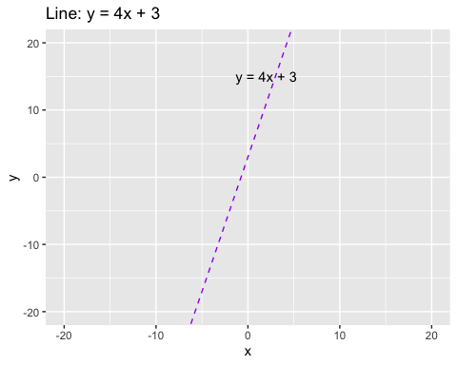

Part Two: Protected Lands
Question 1
# Read the data
data <- read.csv("~/Documents/PAI741/Problem Set Four/data/protected_lands.csv")
# Q1: Find mean, standard deviation and range of each variable:
# protected_lands, gdp_percap, tot_gdp_billions
# protected_lands
mean(data$protected_lands)
[1] 18.38462
sd(data$protected_lands)
[1] 10.89754
range(data$protected_lands)
[1] 4 42
# gdp_percap
mean(data$gdp_percap)
[1] 25210.38
sd(data$gdp_percap)
[1] 19337.7
range(data$gdp_percap)
[1] 3156 58553
# tot_gdp_billions
mean(data$tot_gdp_bilions)
[1] 1125.923
sd(data$tot_gdp_bilions)
[1] 3056.297
range(data$tot_gdp_bilions)
[1] 20 11199
# Q2: Create scatterplot where protected_lands is on y,
# gdp_percap is on x. Include title and axis labels
plot(data$gdp_percap, data$protected_lands,
main = "Protected Lands and GDP Per Capita",
xlab = "GDP Per Capita",
ylab = "Protected Lands",
pch = 16)
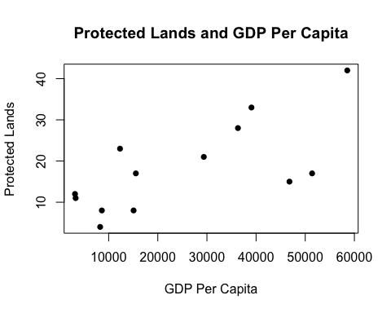
# Q3: Create scatterplot where protected_lands is on y,
# tot_gdp_billions is on x. Include title and axis labels
plot(data$tot_gdp_bilions, data$protected_lands,
main = "Protected Lands and Total GDP",
xlab = "Total GDP (Billions)",
ylab = "Protected Lands",
pch = 16)
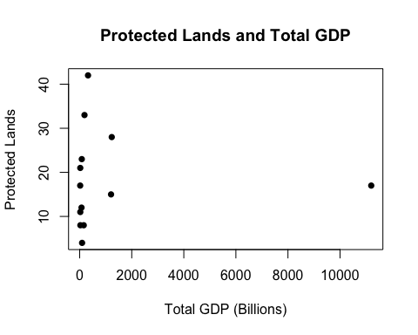
# Q4: Regress protected_lands on gdp_percap
model1 <- lm(protected_lands ~ gdp_percap, data = data)
summary(model1)
Call:
lm(formula = protected_lands ~ gdp_percap, data = data)
Residuals:
Min 1Q Median 3Q Max
-11.925 -6.373 1.292 5.223 10.420
Coefficients:
Estimate Std. Error t value Pr(>|t|)
(Intercept) 8.4075115 3.7882055 2.219 0.04842 *
gdp_percap 0.0003958 0.0001210 3.272 0.00744 **
---
Signif. codes: 0 '***' 0.001 '**' 0.01 '*' 0.05 '.' 0.1 ' ' 1
Residual standard error: 8.103 on 11 degrees of freedom
Multiple R-squared: 0.4932, Adjusted R-squared: 0.4471
F-statistic: 10.7 on 1 and 11 DF, p-value: 0.007443
# Q5: Create scatterplot where protected_lands is on y,
# gdp_percap is on x and overlay with best fit line
plot(data$gdp_percap, data$protected_lands,
main = "Protected Lands and GDP Per Capita",
xlab = "GDP Per Capita",
ylab = "Protected Lands",
pch = 16)
abline(model1, col = "blue", lwd = 2)
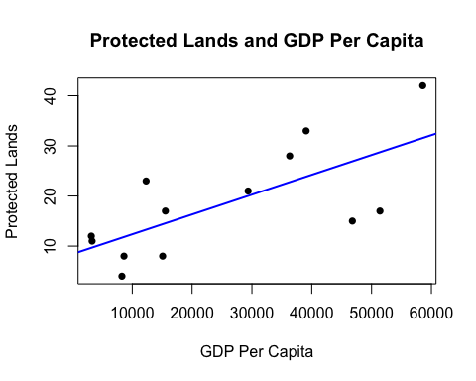
# Q6: Regress protected_lands on tot_gdp_billions
model2 <- lm(protected_lands ~ tot_gdp_bilions, data = data)
summary(model2)
Call:
lm(formula = protected_lands ~ tot_gdp_bilions, data = data)
Residuals:
Min 1Q Median 3Q Max
-14.393 -7.394 -1.394 4.607 23.609
Coefficients:
Estimate Std. Error t value Pr(>|t|)
(Intercept) 1.839e+01 3.381e+00 5.440 0.000204 ***
tot_gdp_bilions -8.177e-06 1.075e-03 -0.008 0.994067
---
Signif. codes: 0 '***' 0.001 '**' 0.01 '*' 0.05 '.' 0.1 ' ' 1
Residual standard error: 11.38 on 11 degrees of freedom
Multiple R-squared: 5.26e-06, Adjusted R-squared: -0.0909
F-statistic: 5.786e-05 on 1 and 11 DF, p-value: 0.9941
# Q7: Create scatterplot where protected_lands is on y,
# tot_gdp_billions is on x. Overlay plot with best fit line
plot(data$tot_gdp_bilions, data$protected_lands,
main = "Protected Lands and Total GDP",
xlab = "Total GDP (Billions)",
ylab = "Protected Lands",
pch = 16)
abline(model2, col = "red", lwd = 2)
